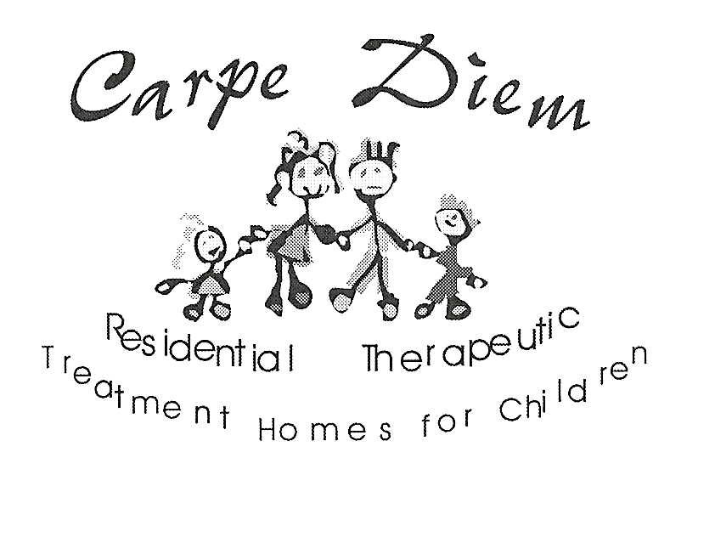

CHILD WELFARE AGENCY RECORD CHECK

CONSENT TO RELEASE OF INFORMATION

I, ____________________________________________ Date of Birth ______________________
(Present full name) (Day/month/year)

Of _____________________________________________________________________________
(Current address)

Hereby consent to a search being made of the records of any Children’s Aid Society in Ontario and / or Child Welfare Organization in Canada. In addition, I also hereby consent to the disclosure of, transmittal to, or examination by CARPE DIEM RESIDENTIAL TREATMENT HOMES FOR CHILDREN INC., ATTENTION: EXECUTIVE DIRECTOR any information in the possession of a Children’s Aid Society in Ontario, and / or Child Welfare Organization in Canada regarding myself as an adult (over 18 years of age).

Past / Other Names: _______________________________________________________________
(Birth name, married name, other names)

Previous 3 Places of Residence:

Complete Address______________________________________________ Year From/To____________

Complete Address_______________________________________________Year From/To____________

Complete Address_______________________________________________ Year From/To___________

Signed by _____________________________________________ Date ____________________

Witnessed by ___________________________________________ Date ____________________

